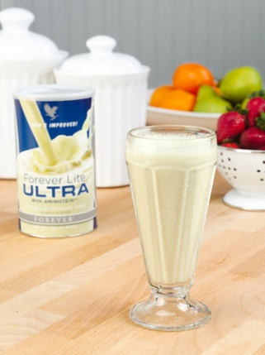
Forever Lite Ultra with Aminotein
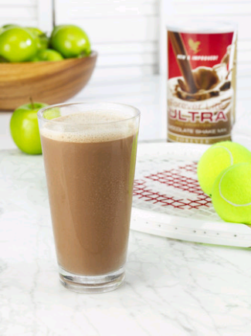
Protein
Protein comes from the greek word “protos” which means -“the first”, “foremost” or “primary” due to the fact that it is of primary importance to our health.

Proteins are essential in muscle, bones, blood, hair, nails and every cell in the body
Proteins are used to build new cells, maintain and repair tissue and make enzymes.
*Nearly half the protein we eat is used to make enzymes.
Enzymes are specialist proteins that perform specific functions such as Digestion, Hormone creation, and creation of various chemicals needed by the body
One of the most important roles of proteins is to produce neurotransmitters.
Neurotransmitters are chemicals that allow nerve cells to communicate with each other, making possible to think, feel, see, hear and move about.
Protein, along with fat and carbohydrates is a Macronutrient, which means that the body needs large amounts of it.
Unlike carbohydrates and fat, the body does not store protein nor can the body manufacture it…so we have to get it from our diet.

Aminotein
Aminotein is a patented proprietary protease blend combined with Forever’s exclusive protein blend added to Forever Lite Ultra to aid in the digestion and absorption of the protein.
Proteases are special enzymes that break down proteins into amino acids that can be absorbed through the intestinal wall and into the bloodstream

*The addition of Aminotein increases the amount of protein actually absorbed by the body.
The charts below represent available amino acids ie digested and absorbed in the body, during the 4hrs after consumption of protein without Aminotein vs with Aminotein
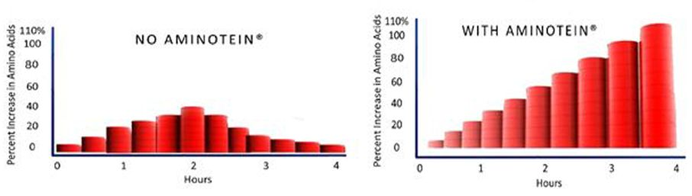
*After protein is digested and absorbed, most of it is used to produce Enzymes, hormones and neuro-transmitters.
*Many of these need certain Vitamins and Minerals to function properly.
*The addition of these vitamins and minerals in their proper quantities and ratios to Forever Lite Ultra adds to the body’s ability to make full use of them.
*Guarantees right amounts of high quality protein in your diet
*For those trying to lose weight , it is a perfect meal replacement

